NAME: JAYA PRAKASH .M
DEPARTMENT: B.E BIOMEDICAL ENGINEERING
COLLEGE: 8151- DHANALAKSHMI SRINIVASAN INSTITUTE OF TECHNOLOGY, SAMAYAPURAM, TRICHY
NAANMUDHALVAN COURSE: DIGITAL MARKETING
NM ID: 290A2C6C73B2793B11D468715EFE416C
NM TEAM ID: NM2023TMID02386

ASSIGNMENTS ON DIGITAL MARKETING
1. Create a Blog or Website using Blogspot and Wordpress. Customize the theme design and post new articlre with 500 words.
Wordpress URL:
https://menzclub4.wordpress.com/2023/10/19/introducing-mens-club-elevate-your-grooming-game/
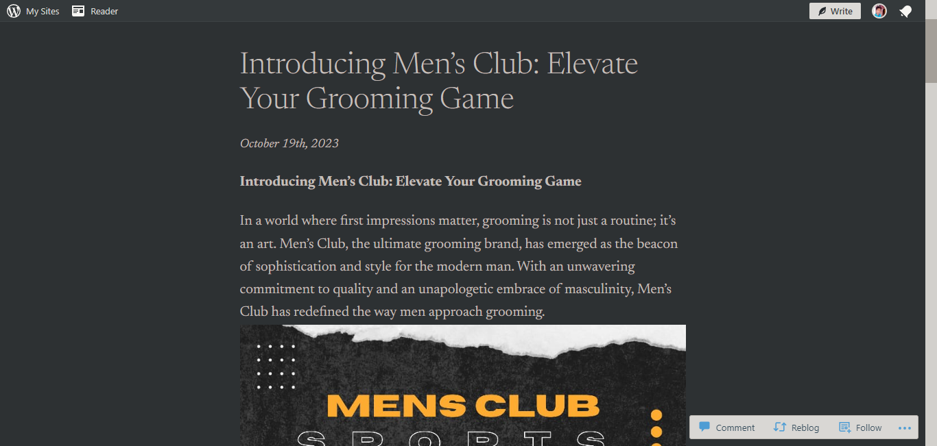

2.Create a New Facebook Business Page and Post One Social Media Poster for your brand.
https://www.facebook.com/mensclub0
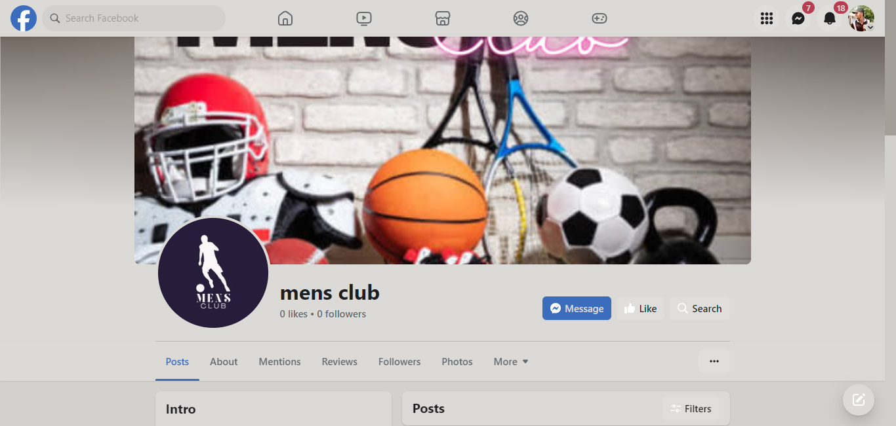

3.Create and design a social media advertisement poster using canva.

4. Create email news letter design using Canva or mail chimp.


